CANDOER News

A quarterly Newsletter dedicated to Communicators AND Others Enjoying Retirement

April 2018 Spring Issue Volume 18 – Number 1

Inside this issue

Cat's Corner 2
By Bob Catlin

Unforgettable Character 2
By Mike McCaffrey

Humor 2

A Trip to Iraq 3
By Jim Davidson

A Retiree’s Life 4
By Roy McCabe

WD-40 5

Welcome to the latest issue of the Newsletter dedicated to the CANDOERs (Communicators AND Others Enjoying Retirement). This Newsletter will be published quarterly. New issues will be posted on the Web for your reading enjoyment on or about, January 1, April 1, July 1, and October 1.
The CANDOER web site and Newsletter may be viewed at: www.candoer.org.
The success of this newsletter depends on you. I need story contributors.
Do you have an interesting article, a nostalgia item, or a real life story you would like to share with others? If you do, please send it to me at the following e-mail address: candoercat@gmail.com
or to my snail-mail address:
Robert J. Catlin, Sr.
2670 Dakota Street
Bryans Road, MD 20616-3062
Tel: Cell -> (301) 535-9263
Home -> (301) 283-6549
Please, NO handwritten submissions.
This newsletter is available on the Web only, free, to any and all.
None of the material in this newsletter has a copyright, unless otherwise noted. If you wish to print the newsletter, and/or make copies to distribute to others, please feel free to do so.
The Newsletter will be available in three formats: as a Web Page; as an Adobe PDF file; and as a Microsoft Word document.
The PDF file and Microsoft Word document will allow you to download and print the newsletter exactly as if I had printed it and mailed it to you.

Cat's Corner

Well spring has arrived in Southern Maryland after a long dry winter. We had an unusual winter. In January we set records for dryness and temperatures. The boat has been taken out of mothballs but due to some health issues I have not been able to get out for out yellow perch, white perch and bass, yet!

Unforgettable Character
By Mike McCaffrey

We all meet all sorts of people during our FS endeavors. And there’s times one or two people tend to stand out in our minds, no matter how long ago we initially met along the way. I nominate one LENNY LANE!
The assignment was special: Bonn (Embassy). Bonn, for those unfortunate to have not served there, HAD IT ALL: good housing on a large compound, the compound was right along the magnificent Rhine River (though moved back enough to never be bothered by the yearly winter/spring flooding), “toy boats” bobbing in the river, “toy castles” on the hills, large expanses of lawns with trees. In addition to the visual appeal, we also had: a commissary, Stars and Stripes bookstore, filling station/garage on compound, large movie theater, and excellent DOD School. We also had Little League fields and a large football field with stands for the high school football and kid’s soccer games. Was it “Little America?” You bet! Very many, if not all, even bought the red BONN warmup jackets (we still have ours). There was a tangible SPIRIT in that BONN community, we loved it!
Department had two Commcenters in Bonn. One, BAX, was situated in the housing compound. The other in the Embassy itself, downstream a short distance from the compound. I was stationed at the Embassy for my tour there.
We primarily worked shift work during my time in Bonn. The Commcenter ran three shifts: Days/Swings/Mids. There were also a few people other than the CPO and CCO who worked straight days, five days per week. One of the “others” was a guy named Lenny Lane. Lenny was somewhat older than most of us and, to those who didn’t get to know him, pretty cranky. Lenny was in charge of “special projects,” which included diplomatic pouch. I recall one day a call came in to his section and Lenny answered. Before we knew it, Lenny was just about screaming to whoever was on the other end, and he eventually slammed the phone down. The CPO at the time was in the Commcenter (the CPO was in charge of both the Embassy and BAX Commcenters) on a matter and observed Lenny’s animated conversation. He asked Lenny (who was red in the face) what that was all about. Seems the call came from the office of The Supreme Allied Commander of NATO (General Alexander Haig back then). I thought the CPO was going to have a heart attack! “For heaven’s sake, Lenny, you can’t talk to that office like that! Haig might be President at some point! What did they want? Call them back right now and apologize!” Lenny did as instructed, but none of us heard what he said, he kept his voice barely audible. I asked Lenny a bit later if he apologized to the apparent sergeant who generated the call, and Lenny gave me his wry smile and said he ended up telling the guy to go to “someplace warm.”
Lenny loved to run daily along the beautiful Rhine, so did I. Thus, we had that mutual interest and ran together at times. This broke the ice, and Lenny and I became good friends. He had a delightful Irish wife, Nora, and we got together with them many times. Lenny would regale us with all sorts of tales, and had us in stitches with his quick … many times irreverent … wit.
One meets a very wide variety of people during a Foreign Service career and, though we remember many, just a relative few have made the kind of impression on me that Lenny did. It was my deep pleasure to have worked with Lenny; I missed him after I moved on from Bonn. The guy made working around him fun.
Blessed are the Whackadoodles, for they let in the light

1. My husband and I divorced over religious differences. He thought he was God and I didn't.
2. I don't suffer from insanity; I enjoy every minute of it.
3. Some people are alive only because it's illegal to kill them.
4. I used to have a handle on life, but it broke.
5. Don't take life too seriously; No one gets out alive.
6. You're just jealous because the voices only talk to me
7. Beauty is in the eye of the beer holder.
8. Earth is the insane asylum for the universe.
9. I'm not a complete idiot -- Some parts are just missing.
10. Out of my mind. Back in five minutes.
11. Nyquil, the stuffy, sneezy, why-the-heck-is-the-room-spinning medicine.
12. God must love stupid people; He made so many.
13. The gene pool could use a little chlorine.
14. Consciousness: That annoying time between naps.
15. Ever stop to think, and forget to start again?
16. Being 'over the hill' is much better than being under it!
17. Wrinkled Was Not One of the Things I Wanted to Be When I Grew up.
18. Procrastinate Now!
19. I Have a Degree in Liberal Arts; Do You Want Fries With That?
20. A hangover is the wrath of grapes.
21. A journey of a thousand miles begins with a cash advance.
22. Stupidity is not a handicap. Park elsewhere!
23. They call it PMS because Mad Cow Disease was already taken.
24. He who dies with the most toys is nonetheless DEAD.
25. A picture is worth a thousand words, but it uses up three thousand times the memory.
26. Ham and eggs ... A day's work for a chicken, a lifetime commitment for a pig.
27. The trouble with life is there's no background music.
28. The original point and click interface was a Smith & Wesson. 29. I smile because I don't know what the heck is going on.

A Trip to Iraq
By Jim Davidson

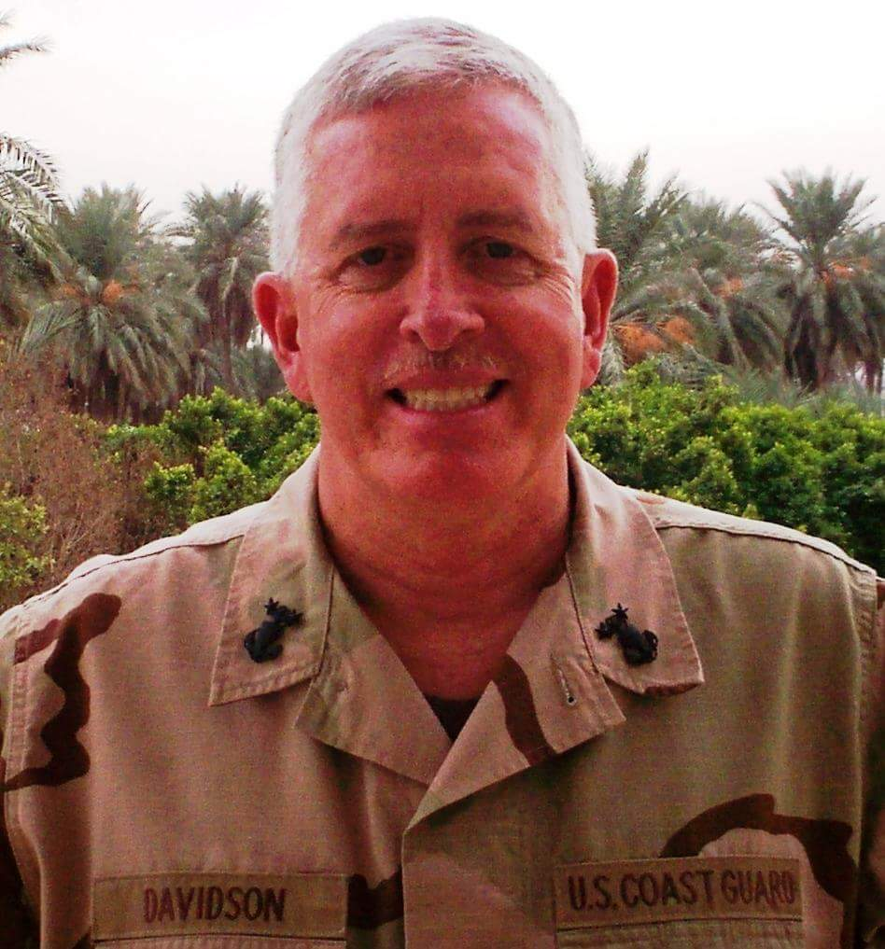

Halloween night 2006, I was aboard a flight in civilian clothes from Dulles to Kuwait. The Coast Guard had recalled me to active duty -- with 48 hours notice -- from my job as IMO Quito. Arriving in Kuwait near midnight, I caught a KBR van to the Hilton – not a bad place to spend a few days on the beach. At the hotel, they gave us meal chits to eat in the restaurant while we awaited transportation to Baghdad.
Thirty hours later we loaded on a bus at 0230 for the trip to an air base. It was hurry up and wait – reminded me of Boot Camp, 30 years earlier. After paperwork and inspections, the base issued PPE (Personal Protection Equipment) – lead vest and Kevlar helmet. Some asked where my weapon was.
I told them Coasties are lovers – not fighters. An unamused Navy chief – we became friends in Baghdad – advised me to roll down my DCU sleeves – not allowed in-theater or at least in Iraq.
It was an eerie morning of 18-year old scared-to-death soldiers loading on flights in full battle gear as 65-year old KBR overweight, been there and elsewhere, veteran contractors watched.
At sunrise our C-130 took off for Baghdad. Just a short flight, the last ten minutes we corkscrewed into “BIAP” or Baghdad International Airport (military side). My ears – even with plugs – suffered through the quick, twisting drop. The gunners were ready, looking intensely out the small windows, testing a few rounds of their 50s.
BIAP was hot, dusty, and full of Army people. I gained respect for the Army; they can sleep anywhere, at any time, wearing anything, and in any weather. When bored, they pull out laptops, MREs, cell phones, and video games from 100 pound packs. They are there for a year – every other year.
No one was there to meet me at BIAP at 0900, but I ran into a departing Homeland Security team who knew who I was. They called Catfish Air to get me on a helo across town, but the earliest would be sunset.
What to do? I had too much weight, suitcases, backpack, vest, and helmet. I caught a bus to the closest camp and found a cot and slept a few hours. Then I found a “DFAC” chow hall where I ate my first free meal in-country, waited in line for an hour to buy a DCU hat (turned out to be USAF version – wrong kind). At 1600 I returned to BIAP and got on a “Catfish” helo to Landing Zone Washington.
The 20 minute flight across the City of Baghdad, with five million inhabitants hiding below, was memorable. Sun-burned, sore, tired, sweating, and thirsty – I thought that now, I was finally in my first war – after 31 years in the part-time Military. The weather cooled, twilight lit up the beauty of the city, and all was suddenly grand and thrilling. Though I was ready, and had friends in Embassy Baghdad, I suddenly realized that this was real stuff, just like Apocalypse Now – and soon found out – even more Mad Max and Good Morning Vietnam movies.
Just before we landed the Blackhawk gunner shot a few flares – it was beautiful. At the LZ a welcome team from my organization awaited in an up-armored SUV. They were hardened U.S. Border Patrol agents – most from Texas – Salt-of-the-Earth who I will always respect. They were glad to see someone arrive to take care of their needs. Since I was both in the Military and State Department, they expected a lot.
They took me to fine hooch complete with satellite TV, Internet, and VOIP telephone. I had a room with a shared bath with the USN command master chief. Then we went to the DFAC and ate lobster and Baskin-Robbins ice cream. Not bad. Will I like it here?
A Retiree’s Life
By Roy McCabe

We moved to Pa to be near Donna’s mother who had lost her husband. I made it a point that we would do nothing but travel, etc.
Here is the saga of an 83 year old (me) and a 77 year old (my wife Donna):
On our first attempt to travel our motor home caught fire on the Pennsylvania turnpike and we lost it. We had Mom, Donna, myself and three dogs and I was towing my car. We all got out of motor home safely. I was able to get the car disconnected and backed away. We sat in it until all the paper work was done. So much for our travel plans.
I was approached about joining the fire department, which I had said I would not do but they put forward a good story so both Donna and I joined. We then both became EMT’s and are still running calls to this date.
I was then conned into a whole bunch of things which is never ending (I just cannot say No!).
I have been on School board for 19years (I have no children in area).
I am on the board of the Center for Community action (with offices in eight counties now).
I am on the board of the Water/Sewer Joint Municipal Authority.
I am on a County Transportation Board (trails and biking).
I am President of the local Lions Club.
I am the Emergency Management coordinator for two towns.
I am a member of the Huntingdon County Emergency Management team.
IT for the entire local area
I repair computers for those that cannot afford to have them repaired (no charge except parts).
I write grants for the Fire Department and Township
I am a member of the local community group. We have built two parks in the town and a little league ball field with lights, all with grants.
Both Donna and I are Lay Speakers in the Methodist Church and give sermons from time to time when necessary.
Donna has or is involved in all these activities, also. We suffer from not much in the way for free time.
Also as a note: big shopping here is 42 miles away and over two mountains and small shopping is 26 miles away and over two mountains. We have a food store 12 miles away. Shopping is an all-day project.
We are Altoona Curve fans and get to about 10 games each year and that is our entertainment.
Oh! Donna is still working one day, three hours a week at our local post office and fills in at other times, when necessary.
Oh! I almost forgot. I still lift weights (small now getting old) every day (can’t run any more have a bad knee).
Oh! Another thing is we are still in training for emergency management and EMT on an almost every day basis. (We are so smart it is scary!)
This is the life of a retired Government worker and family (Donna, Delilah our dog and I).
Oh and I forgot. I have a weather station here that is on Weather Underground (wunderground.com -- Search for zip code 16694). I also report weather to the local TV station and record weather on a daily basis. I am also the Federal precipitation reporter for the area.
Anyone that is bored in retirement move up here. I am sure we can find something for you to do.

WD-40

What Is The Main Ingredient of WD-40?
Before you read to the end, does anybody know what the main ingredient of WD-40?
No Cheating.....WD-40 ~ who knew!
I had a neighbor who bought a new pickup. I got up very early one Sunday morning and saw that someone had spray painted red all around the sides of this beige truck (for some unknown reason). I went over, woke him up, and told him the bad news.
He was very upset and was trying to figure out what to do .... probably nothing until Monday morning, since nothing was open.
Another neighbor came out and told him to get his WD-40 and clean it off. It removed the unwanted paint beautifully and did not harm his paint job that was on the truck. I was impressed! WD-40 who knew?

"Water Displacement #40"

The product began from a search for a rust preventative solvent and degreaser to protect missile parts. WD-40 was created in 1953, by three technicians at the San Diego Rocket Chemical Company. Its name comes from the project that was to find a 'Water Displacement' Compound. They were finally successful for a formulation, with their fortieth attempt, thus WD-40. The 'Convair Company' bought it in bulk to protect their atlas missile parts. Ken East (one of the original founders) says there is nothing in WD-40 that would hurt you. When you read the 'shower door' part, try it. It's the first thing that has ever cleaned that spotty shower door. If yours is plastic, it works just as well as on glass. It's a miracle!
Then try it on your stove-top. It's now shinier than it's ever been.
You'll be amazed. WD-40 Uses:
1. Protects silver from tarnishing.
2. Removes road tar and grime from cars.
3. Cleans and lubricates guitar strings.
4. Gives floor that 'just-waxed' sheen without making them slippery.
5. Keeps the flies off of cows, horses, and other farm critters.
6. Restores and cleans chalkboards.
7. Removes lipstick stains.
8. Loosens stubborn zippers.
9. Untangles jewelry chains.
10. Removes stains from stainless steel sinks.
11. Removes dirt and grime from the barbecue grill.
12. Keeps ceramic/terracotta garden pots from oxidizing.
13. Removes tomato stains from clothing.
14. Keeps glass shower doors free of water spots.
15. Camouflages scratches in ceramic and marble floors.
16. Keeps scissors working smoothly.
17. Lubricates noisy door hinges on both home and vehicles doors.
18. It removes that nasty tar and scuff marks from the kitchen flooring. It doesn't seem to harm the finish and you won't have to scrub nearly as hard to get them off. Just remember to open some windows if you have a lot of marks.
19. Remove those nasty bug guts that will eat away the finish on your car if not removed quickly!
20. Gives a children's playground gym slide a shine for a super-fast slide.
21. Lubricates gearshift and mower deck lever for ease of handling on riding mowers.
22. Rids kids rocking chair and swings of squeaky noises.
23. Lubricates tracks in sticking home windows and makes them easier to open.
24. Spraying an umbrella stem makes it easier to open and close.
25. Restores and cleans padded leather dashboards in vehicles, as well as vinyl bumpers.
26. Restores and cleans roof racks on vehicles.
27. Lubricates and stops squeaks in electric fans.
28. Lubricates wheel sprockets on tricycles, wagons and bicycles for easy handling.
29. Lubricates fan belts on washers and dryers and keeps them running smoothly.
30. Keeps rust from forming on saws and saw blades, and other tools.
31. Removes grease splatters from stove-tops.
32. Keeps bathroom mirror from fogging.
33. Lubricates prosthetic limbs.
34. Keeps pigeons off the balcony (they hate the smell).
35. Removes all traces of duct tape.
36. Folks even spray it on their arms, hands, and knees to relieve arthritis pain.
37. Florida's favorite use is: 'cleans and removes love bugs from grills and bumpers.'
38. The favorite use in the state of New York, it protects the Statue of Liberty from the elements.
39. WD-40 attracts fish. Spray a little on live bait or lures and you will be catching the big one in no time. Also, it's a lot cheaper than the chemical attractants that are made for just that purpose. Keep in mind though, using some chemical laced baits or lures for fishing are not allowed in some states.
40. Use it for fire ant bites. It takes the sting away immediately and stops the itch.
41. It is great for removing crayon from walls. Spray it on the marks and wipe with a clean rag.
42. Also, if you've discovered that your teenage daughter has washed and dried a tube of lipstick with a load of laundry, saturate the lipstick spots with WD-40 and rewash. Presto! The lipstick is gone!
43. If you spray it inside a wet distributor cap, it will displace the moisture, allowing the engine to start.
My discovery, Ants don't like it.
P.S. As for that basic, main Ingredient ...
Well ... it's FISH OIL.
See you next quarter!

KEEP THE STORIES COMING!

Enjoy life and be safe!

